To Supply Leftover Food To Poor
College Name : Chikkanna Government Arts College
College Code : bru06

TEAM ID : NM2025TMID26303
Team LeaderName : SARATHI M
Email :praneshsarathi840@gmail.com
Team Member 1 : SARATHI S
Email : ssivaraja312@gmail.com
Team Member 2 : SASIKUMAR K
Email : kumarkumar75340@gmail.com
Team Member 3 : SELVAKUMAR M
Email:selvakumar8575samalapuram@gmail.com
Team Member 4 :THIRUPATHI S
Email : op.thiru46@gmail.com

INTRODUCTION
Salesforce is a leading cloud-based Customer Relationship Management (CRM) platform that provides versatile tools for managing and optimizing customer relationships, sales processes, and customer service. For this project, aimed at helping supply leftover food to the poor, Salesforce serves as a comprehensive solution that can streamline processes and improve the efficiency of this charitable mission. This chapter will discuss Salesforce's core functions and how they support the goals of the project.
PURPOSE
This project aims to develop a salesforce based application designed to manage and streamline the distribution of leftover food to undeserved communities. The primary goal is to enhance the efficiency of food drop- offs, coordinate tasks, manage volunteers and generate insightful reports.

DEVELOPMENT PHASE
Creating Developer Account
By using this URL - https://www.salesforce.com/form/developer-signup/?d=pb

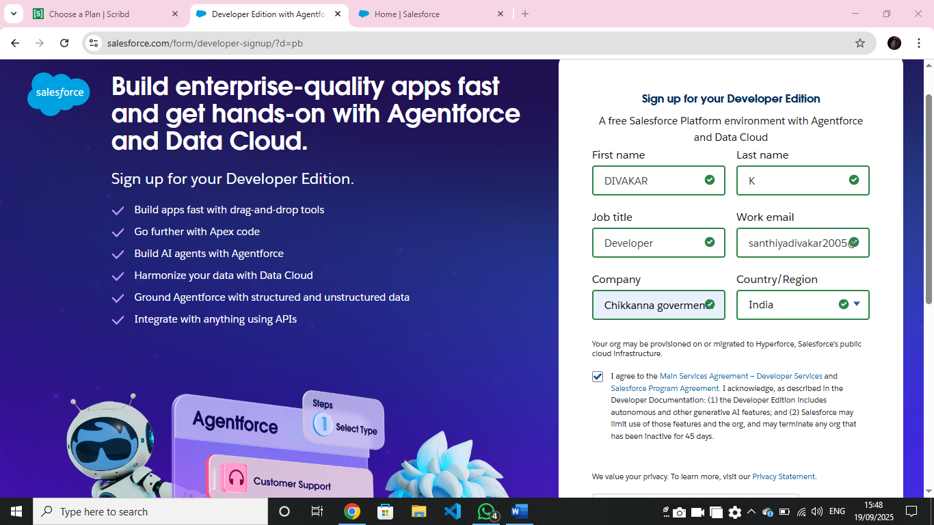
Object creation
- Created object : Venue, Drop-Off Point, Task, Volunteer, Execution Details

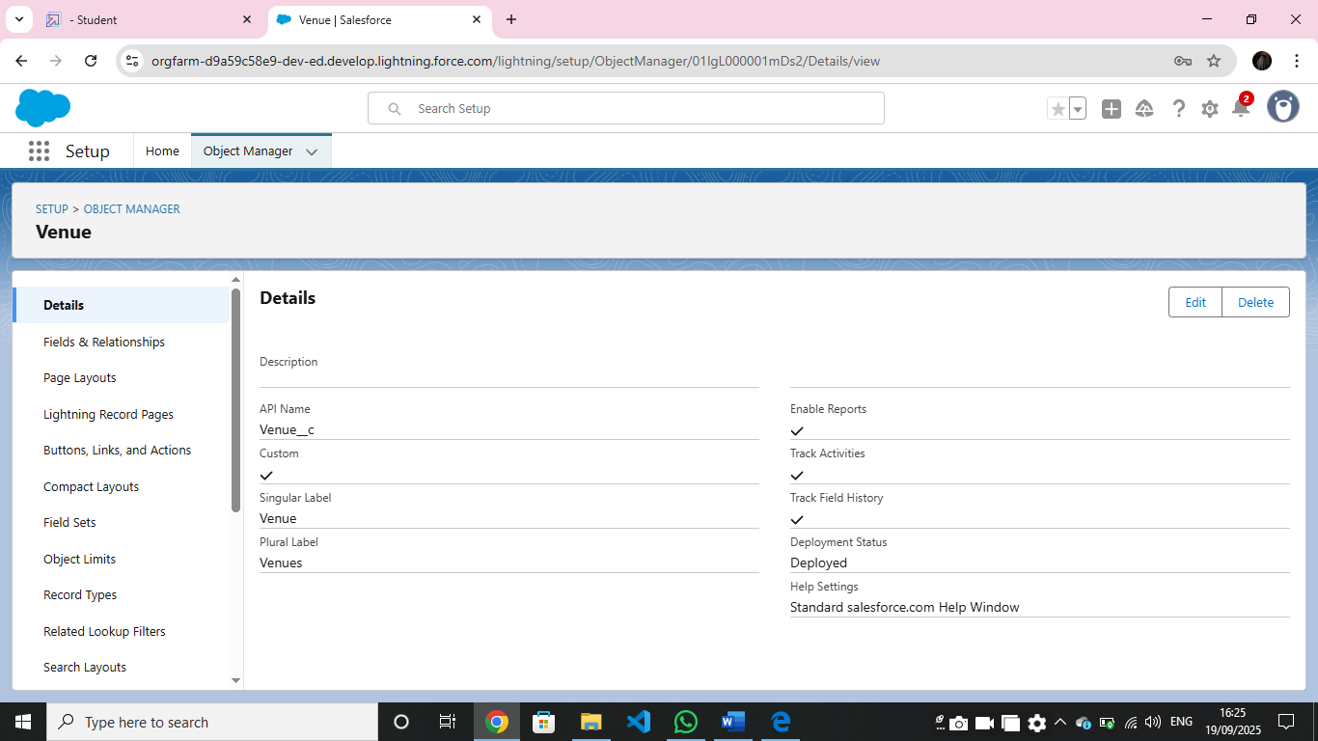

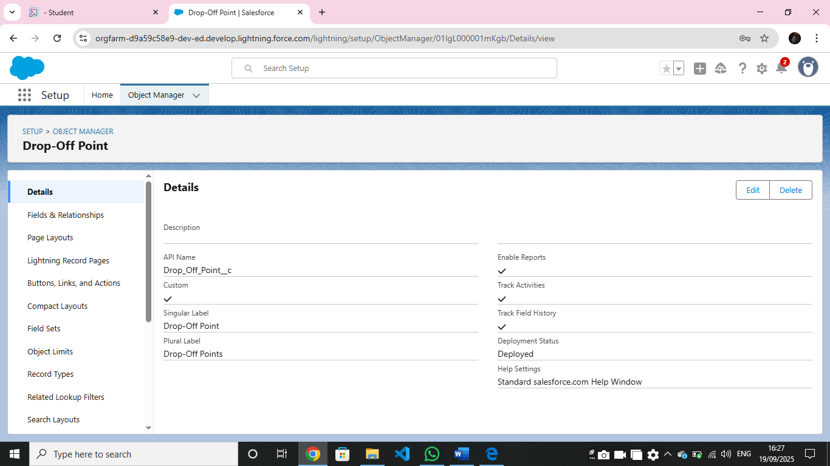
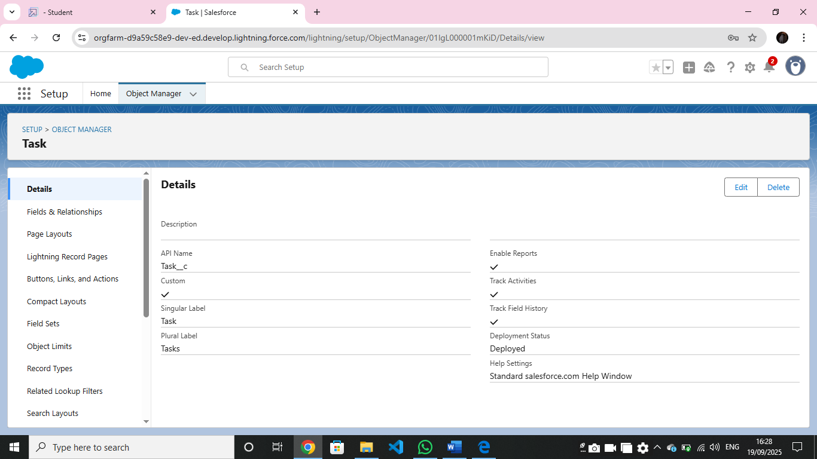

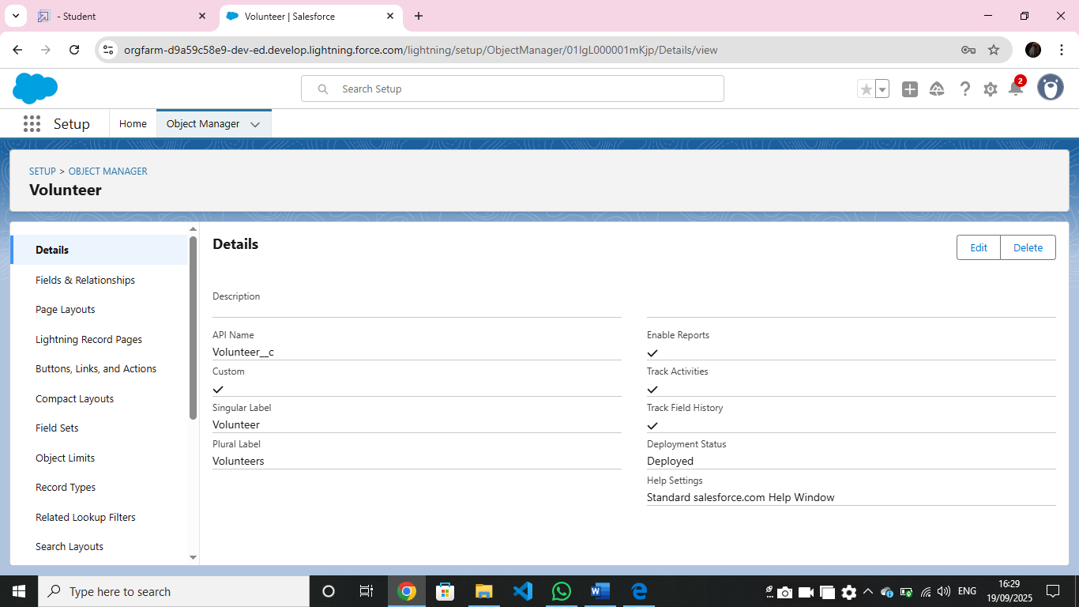

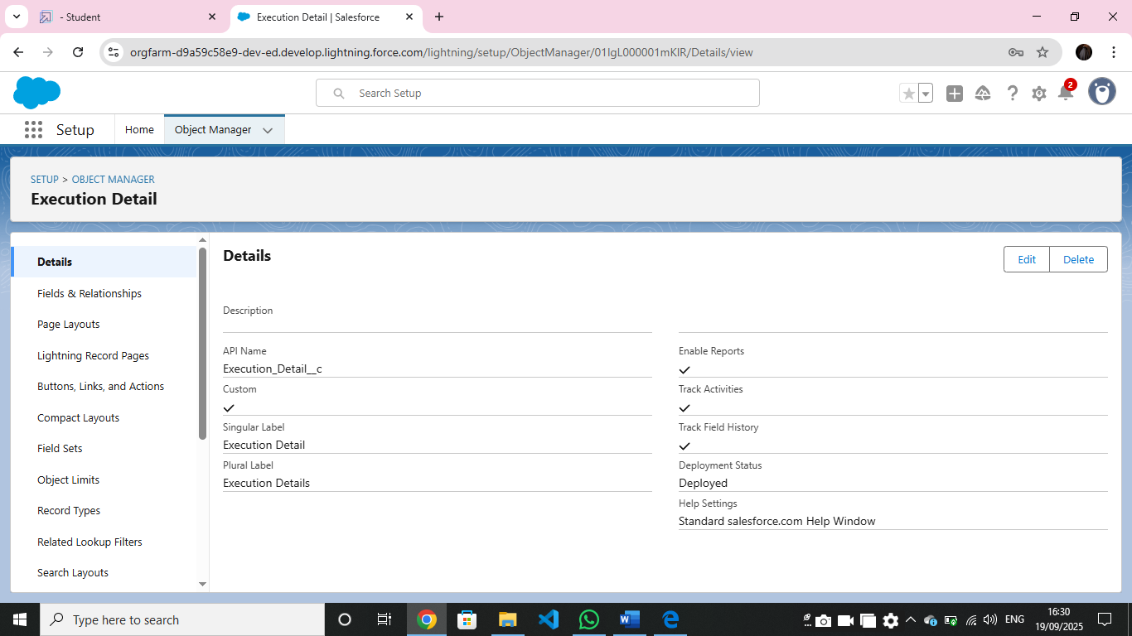

Tabs
- Creating Tabs , tabs will represent each key object—like Venue, Drop-Off Point, Execution Details, Volunteer, and Task—allowing users to quickly access, view, and update records.
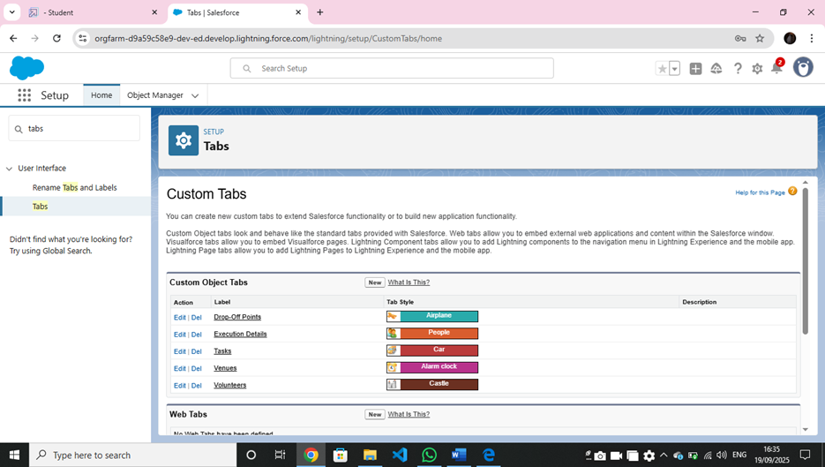

Lightning apps
- Lightning Apps in Salesforce consist of a set of tabs and components that work together to enable specific functions.

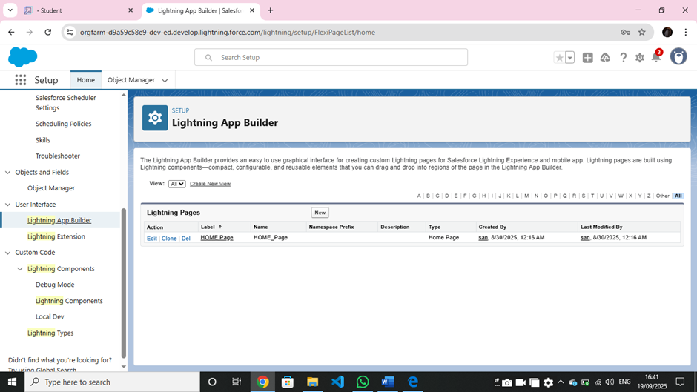

Fields
- Creating fields , Here’s a detailed guide on setting up fields, relationships, and creating key objects like Venue, Drop-Off Point, Task, Volunteer, and Execution Details.
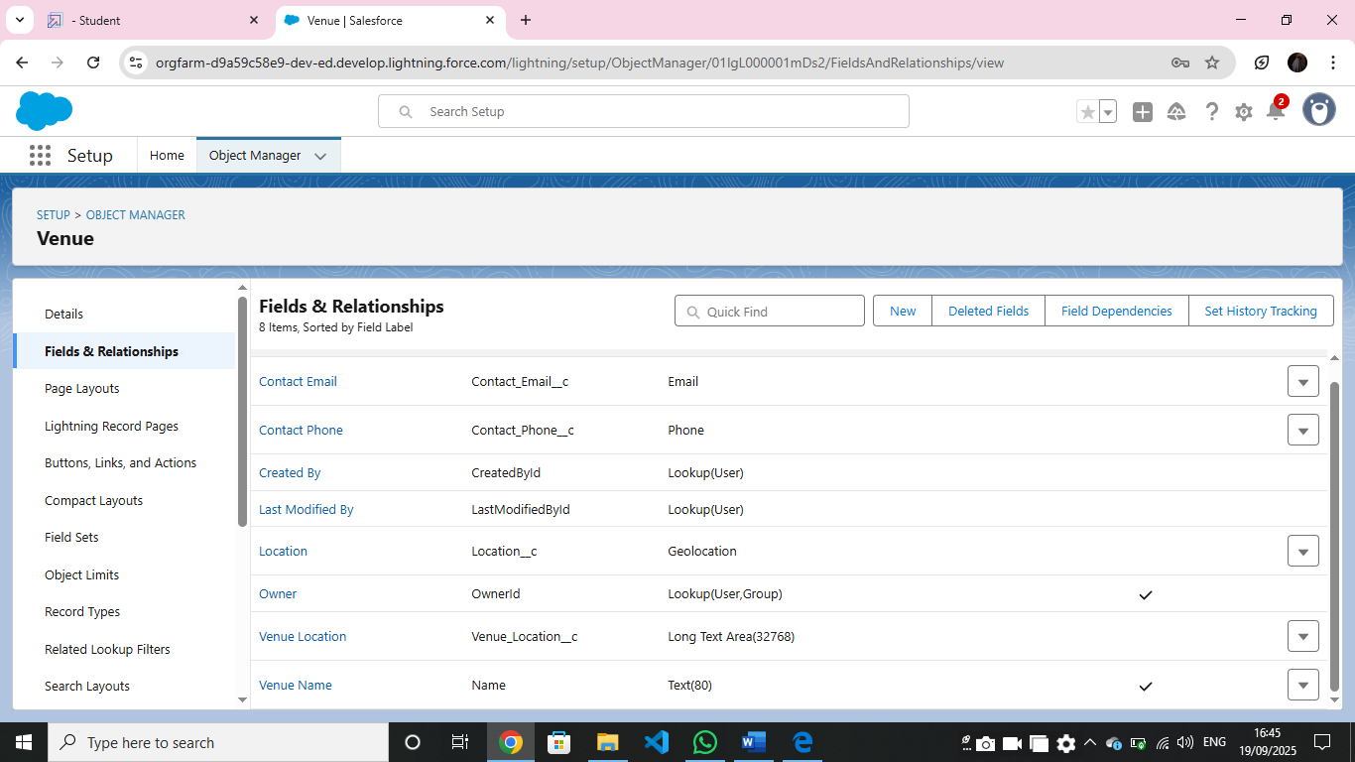

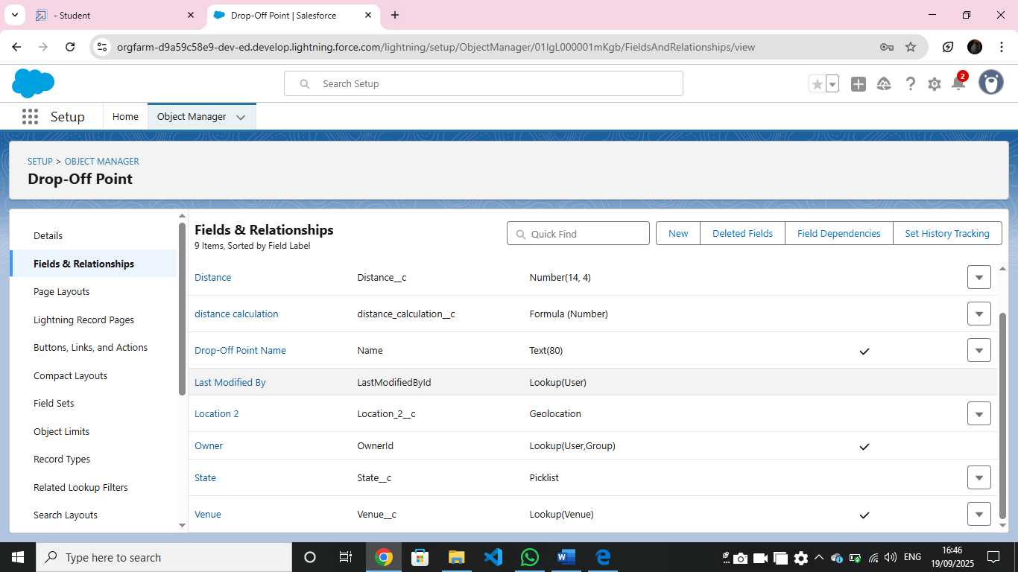

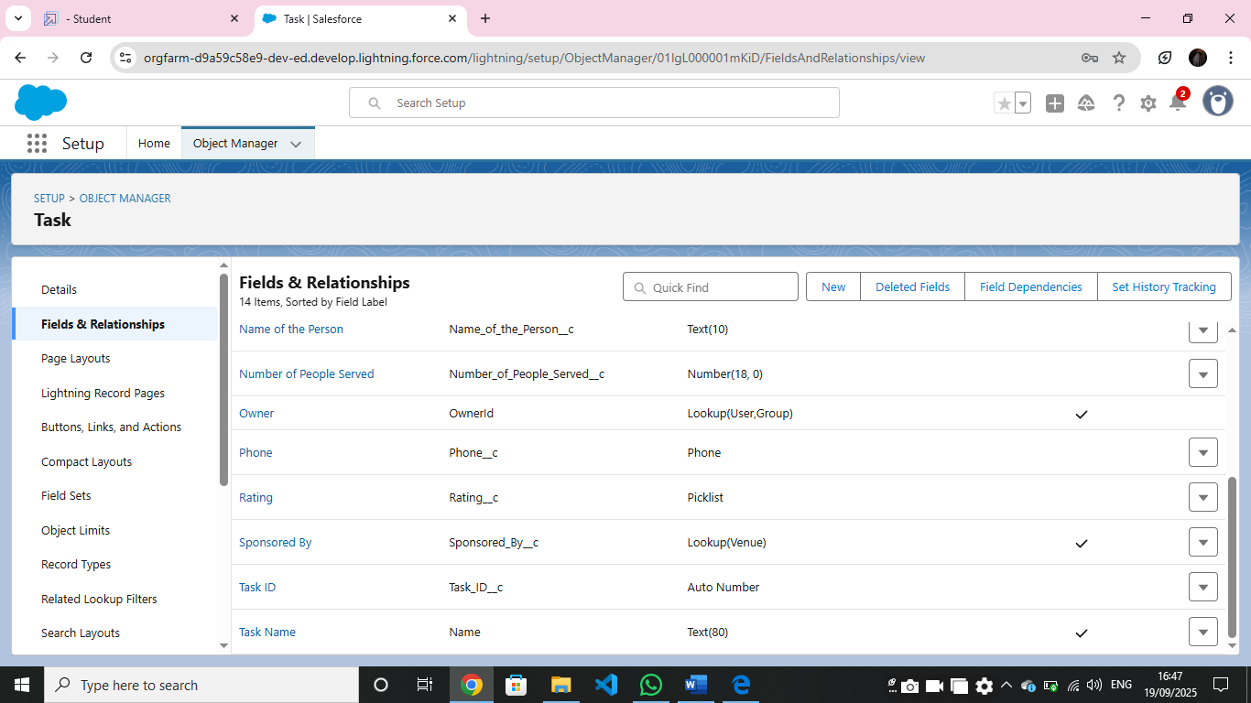

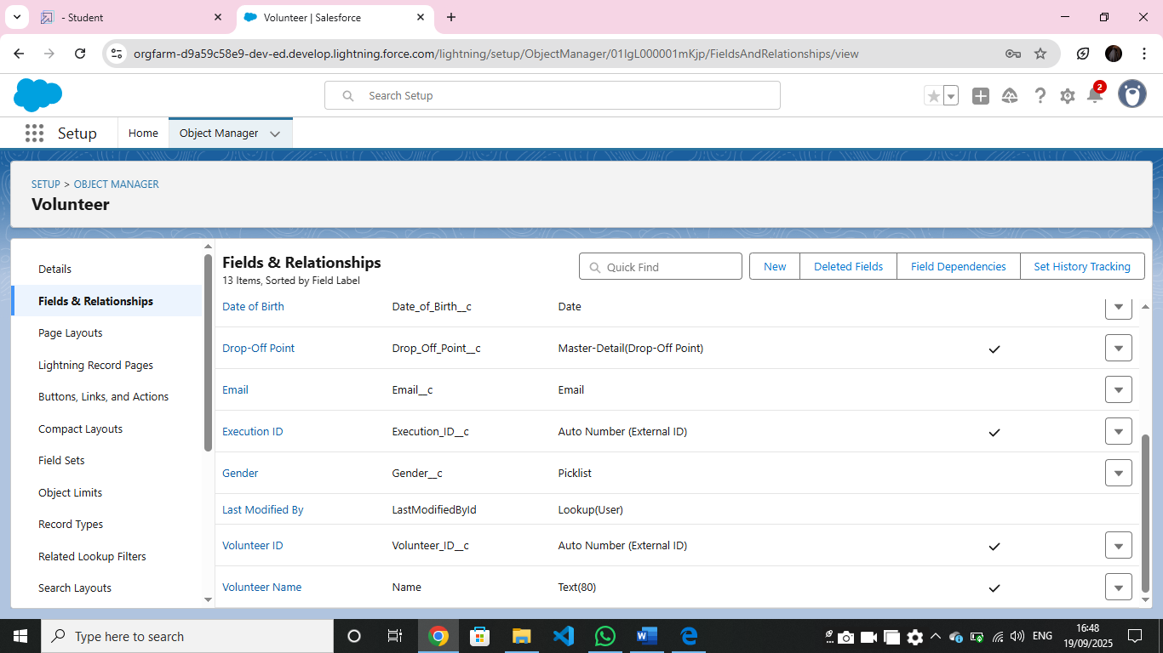

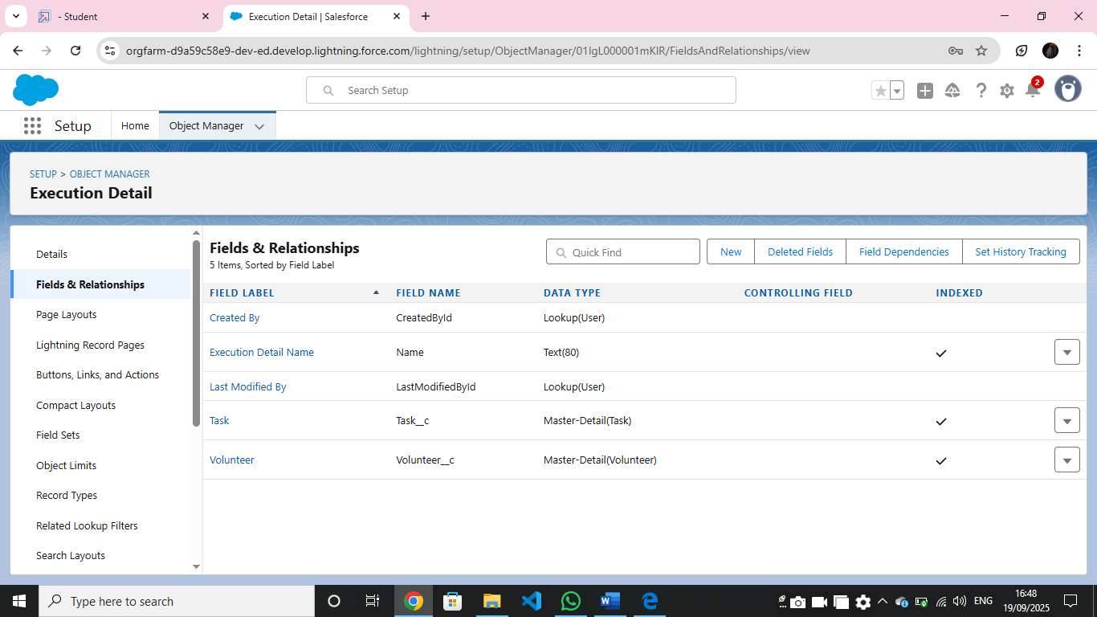

Flows
- Flows are powerful automation tools that can automate processes such as record creation, updates, notifications, and complex logic.

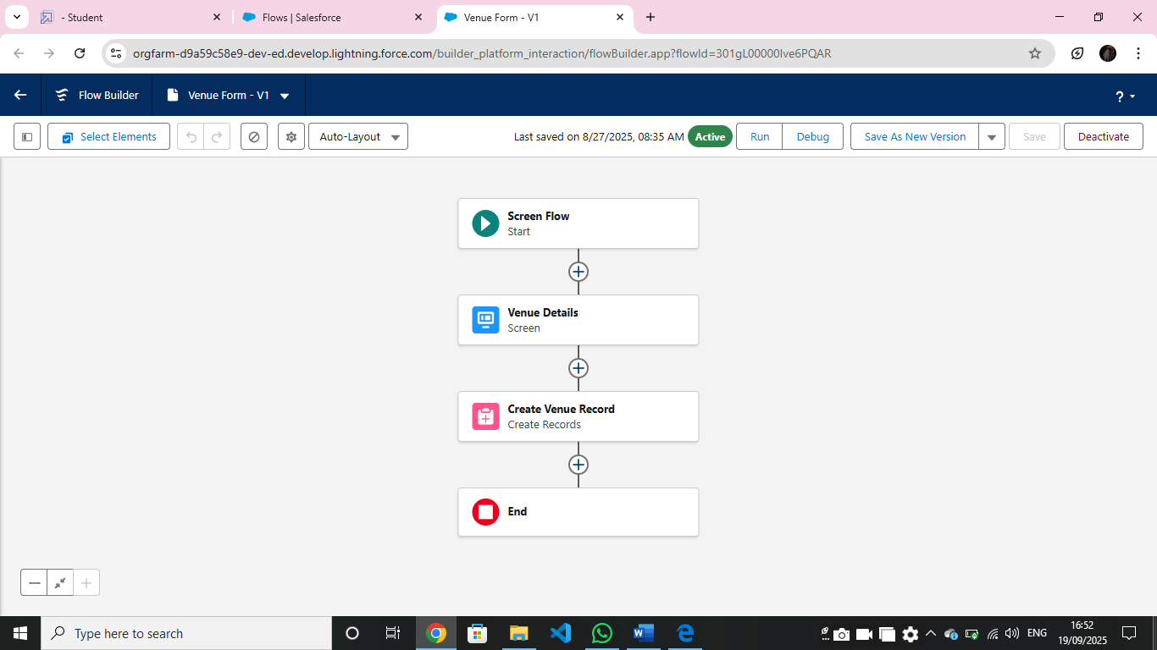

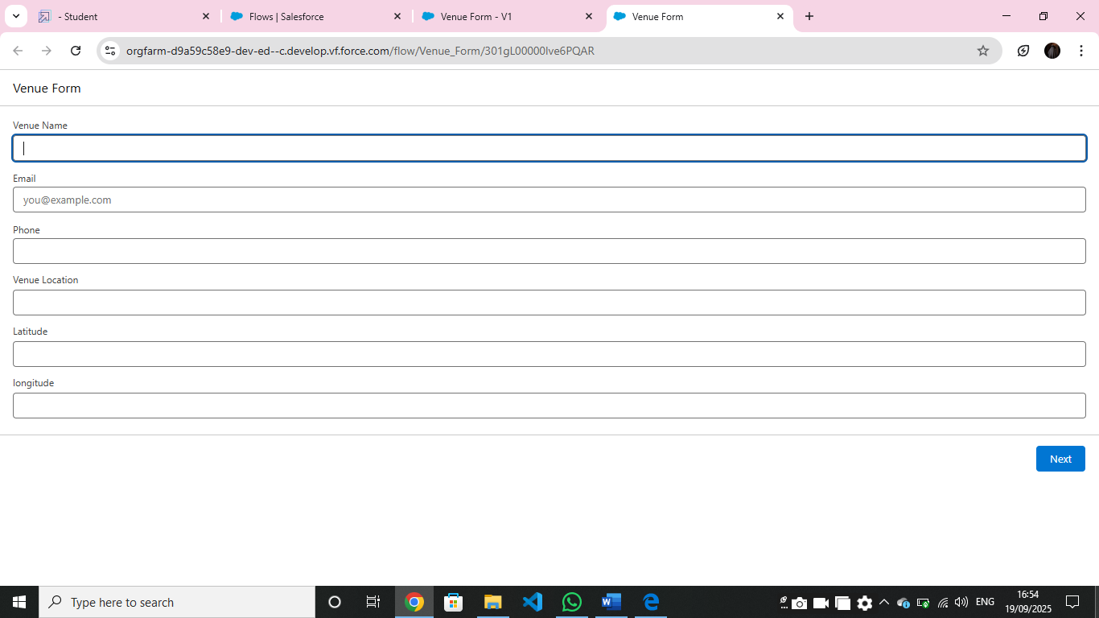
Triggers
- To create a trigger in Salesforce that automatically creates a record in the Venue object based on a specific condition or event you'll need to write an Apex Trigger.

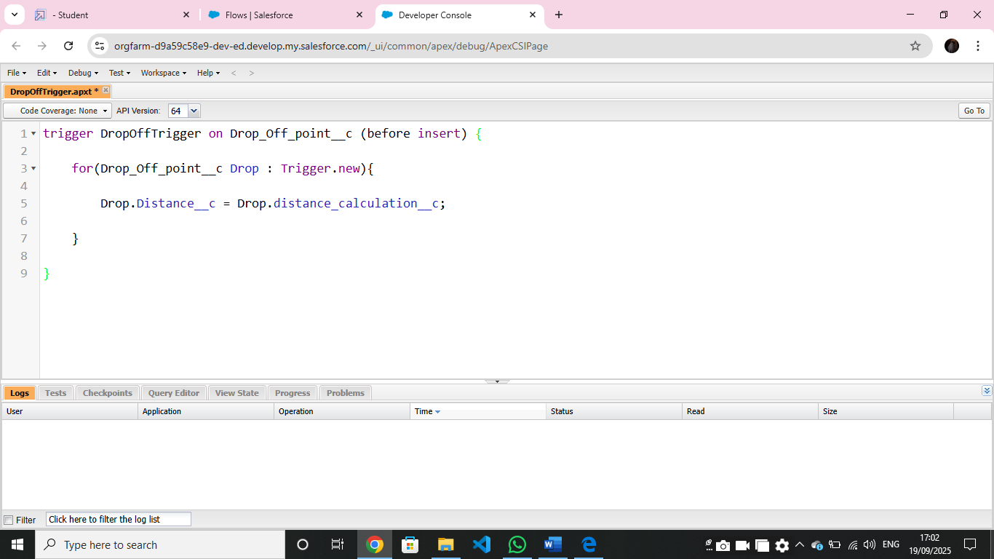

Profiles
- Profiles are crucial for controlling user access to data, objects, and specific features within your app. Profiles define user permissions, such as object permissions, field-level security, app settings, and more.

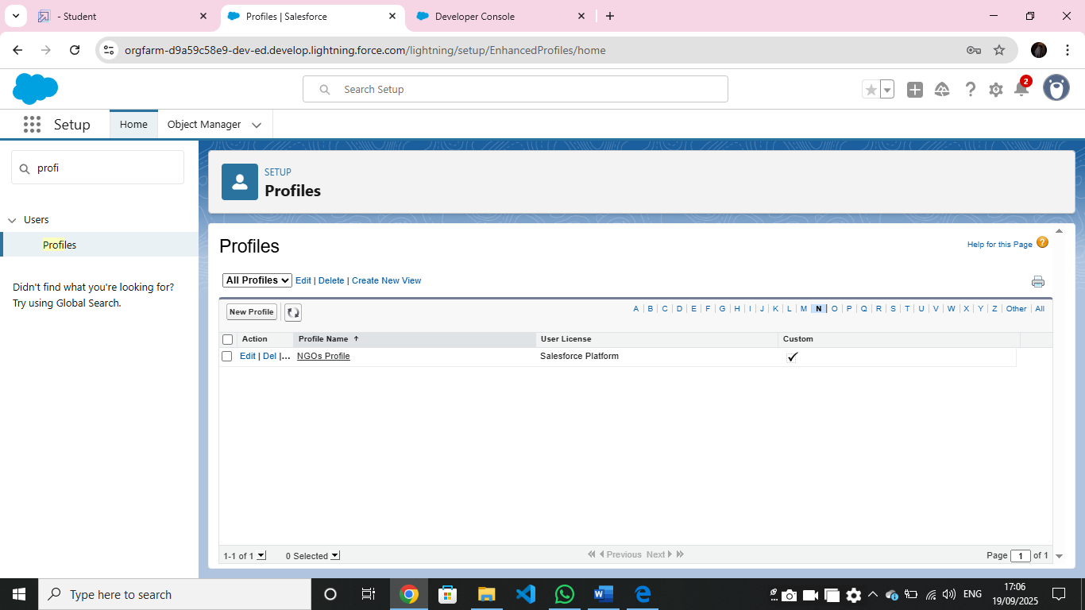

Users
- Creation of users , users are the peoples who can access the system
- Here I have created some users like Iksha Foundation, NSS, Street Cause .

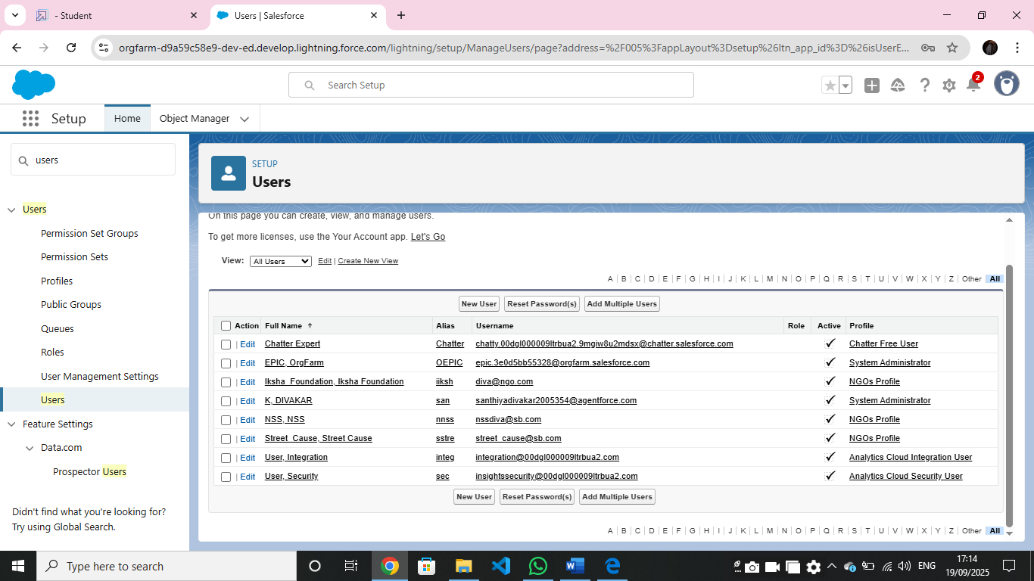

Public Group
- Public groups are the collection of users we group them to share their rules ,etc .
- Here I grouped Iksha, NSS, Street Cause .

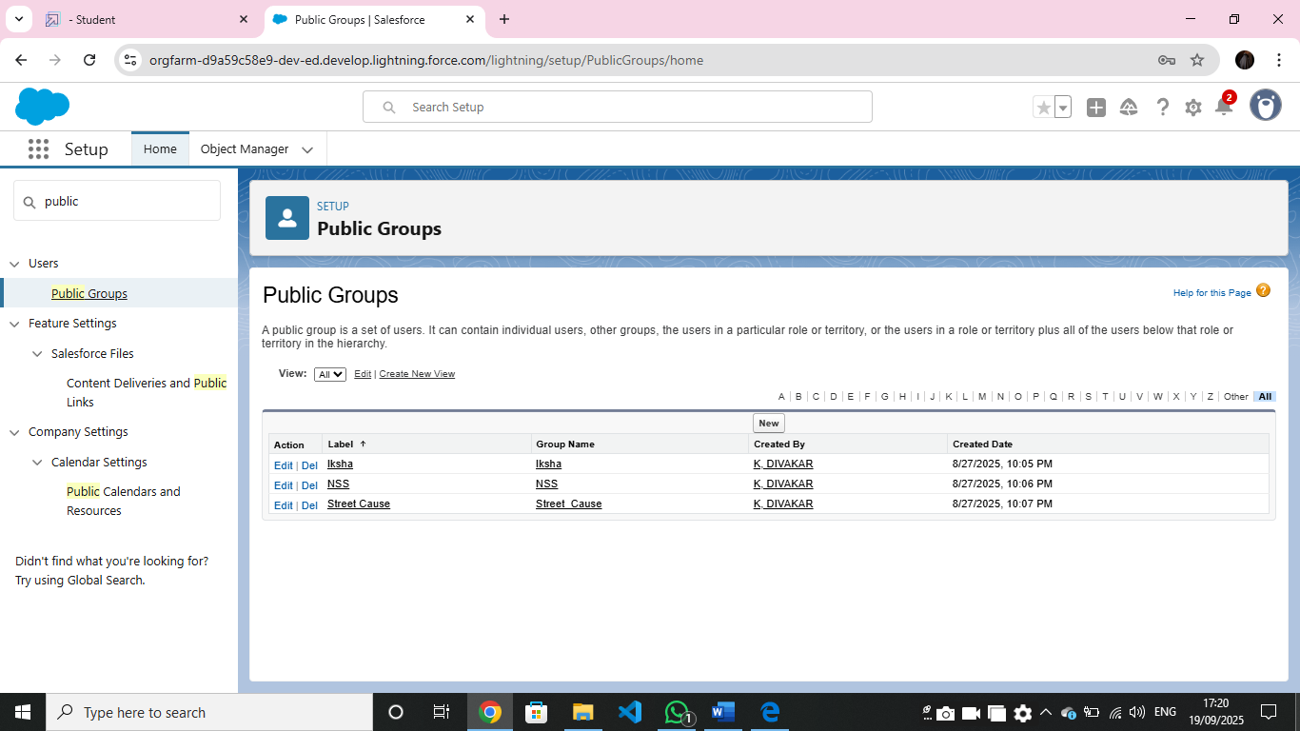

Report types
- Report Types define the set of data and relationships that reports can access by customizing report types, such as tracking venue usage, volunteer participation, or task completion for your food distribution project

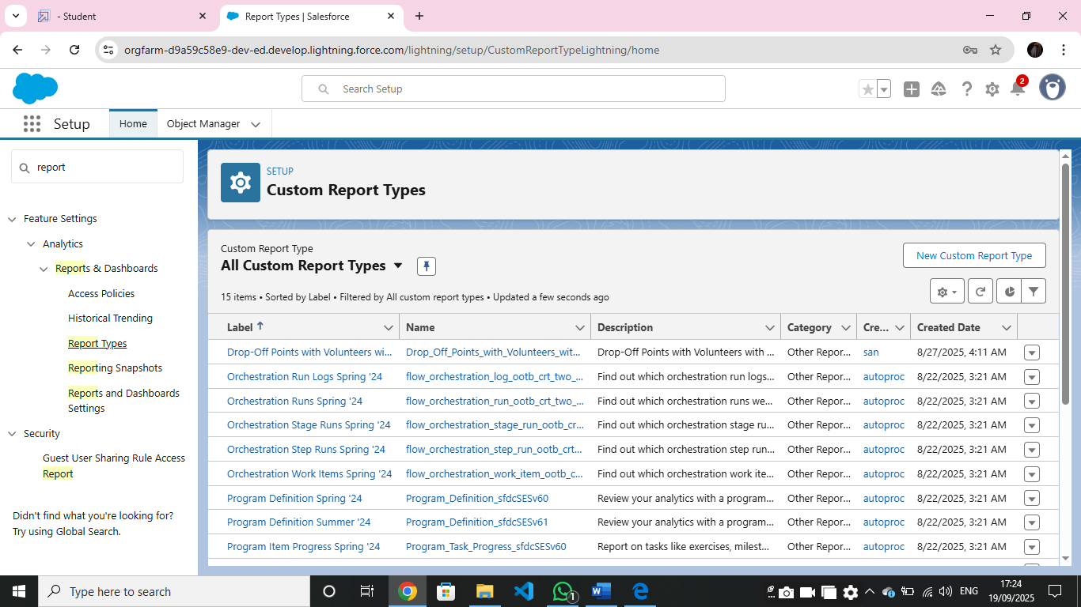

Report
- Reports are created in report type fields , it created to show Venue Name, Drop-Off point Name, Distance to the users

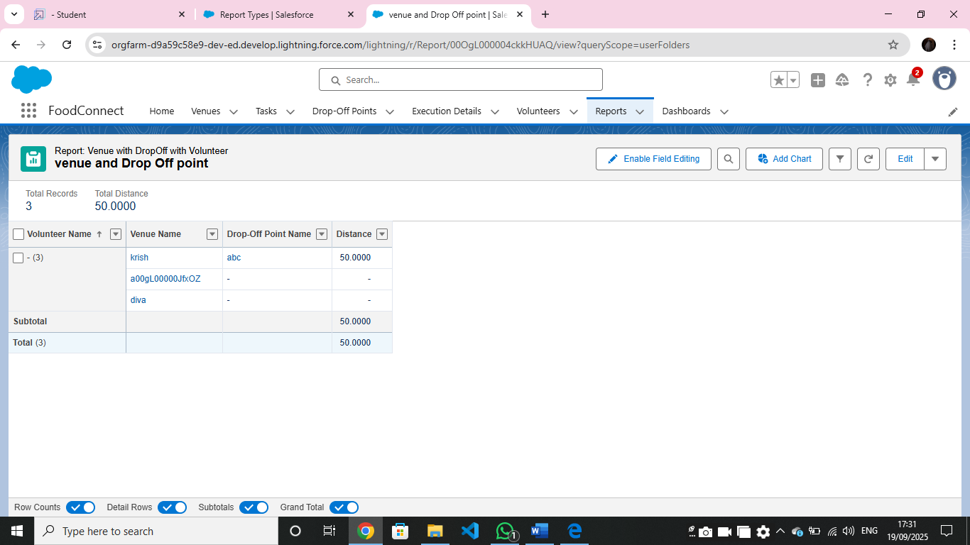

Dashboards
- Dashboards are visual representations of data collected from reports, allowing users to monitor key metrics and gain insights at a glance. Dashboards are built using components (e.g., charts, tables, metrics), each representing a report

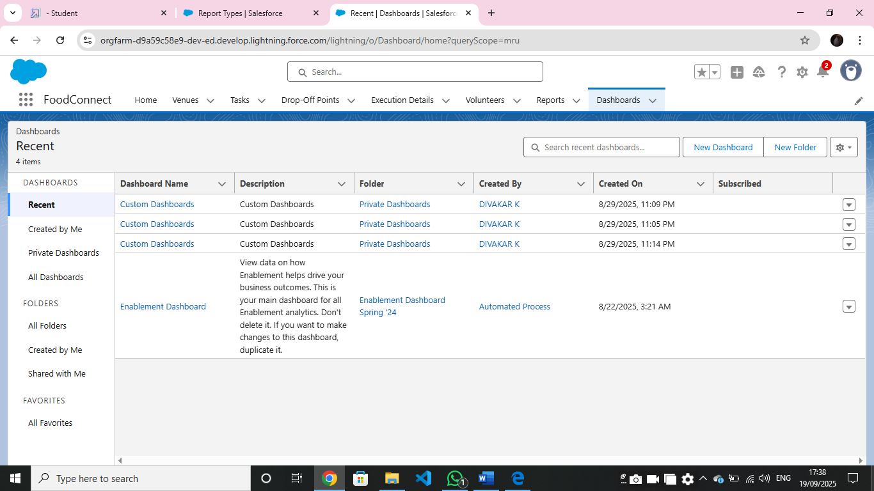

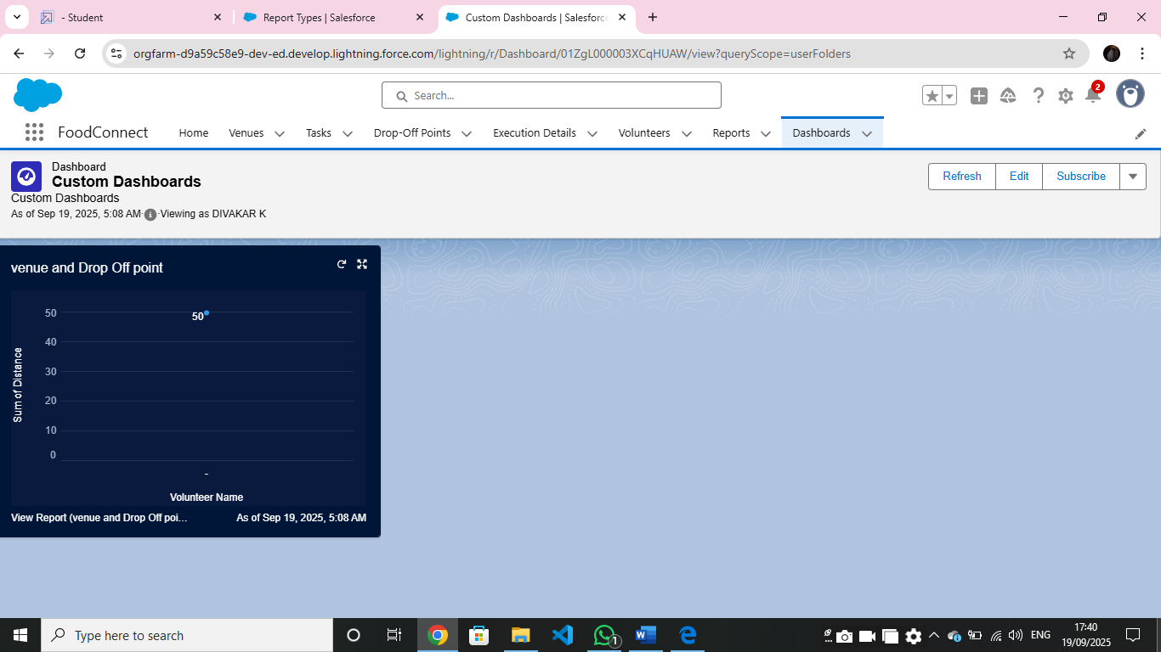

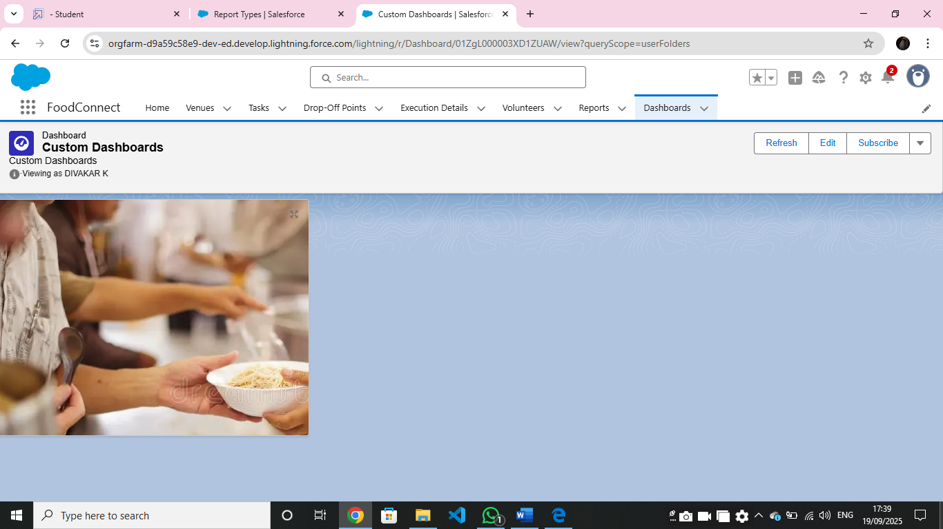
Sharing rules
- Organization-Wide Defaults (OWD). Sharing rules allow you to share records with particular users, roles, or groups based on either ownership or field-based criteria .

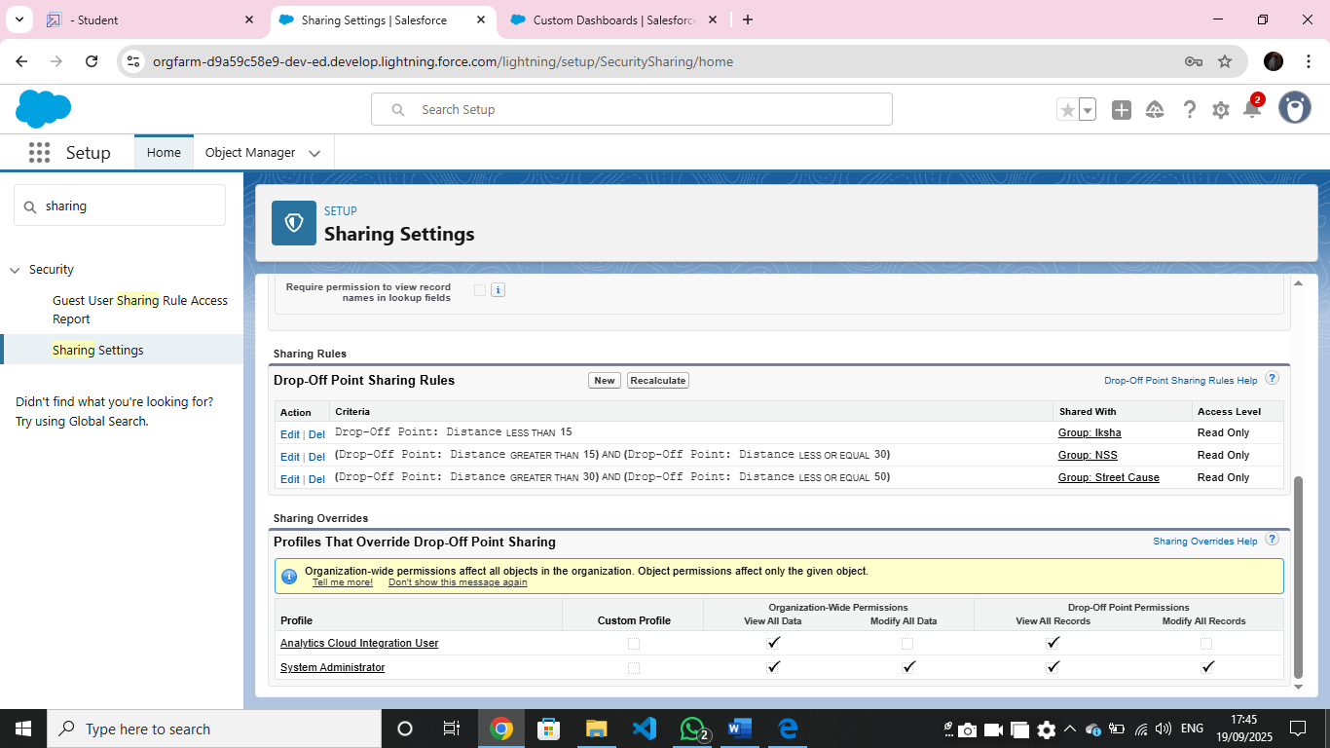

Homepage
- Creating a Home Page in Salesforce allows you to design a personalized landing page that displays key metrics, quick links, and other components users need when they first log in. For your food distribution project, a custom home Page can include components like recent venues, task updates, and volunteer assignments to streamline navigation and increase efficiency

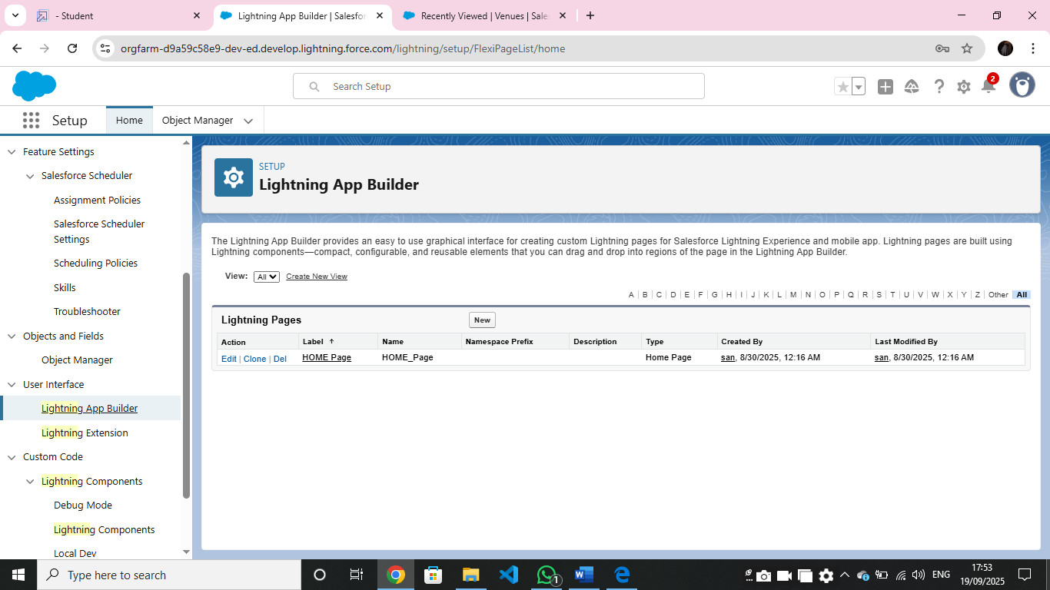
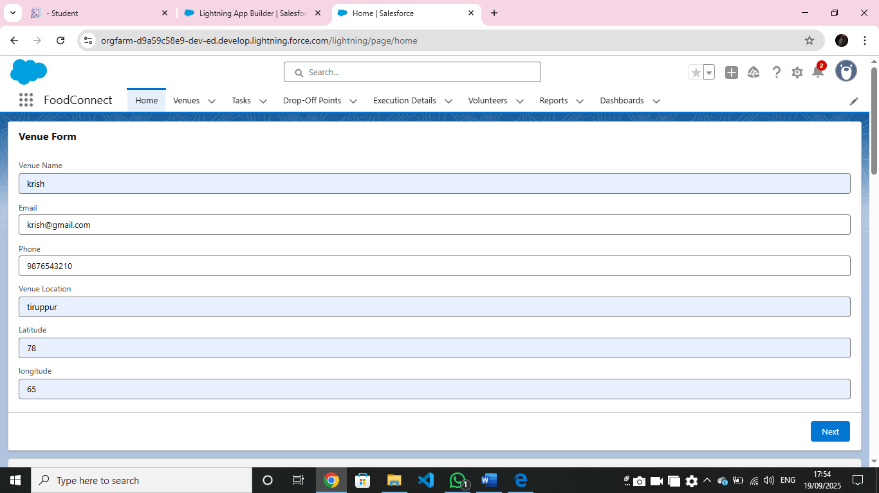

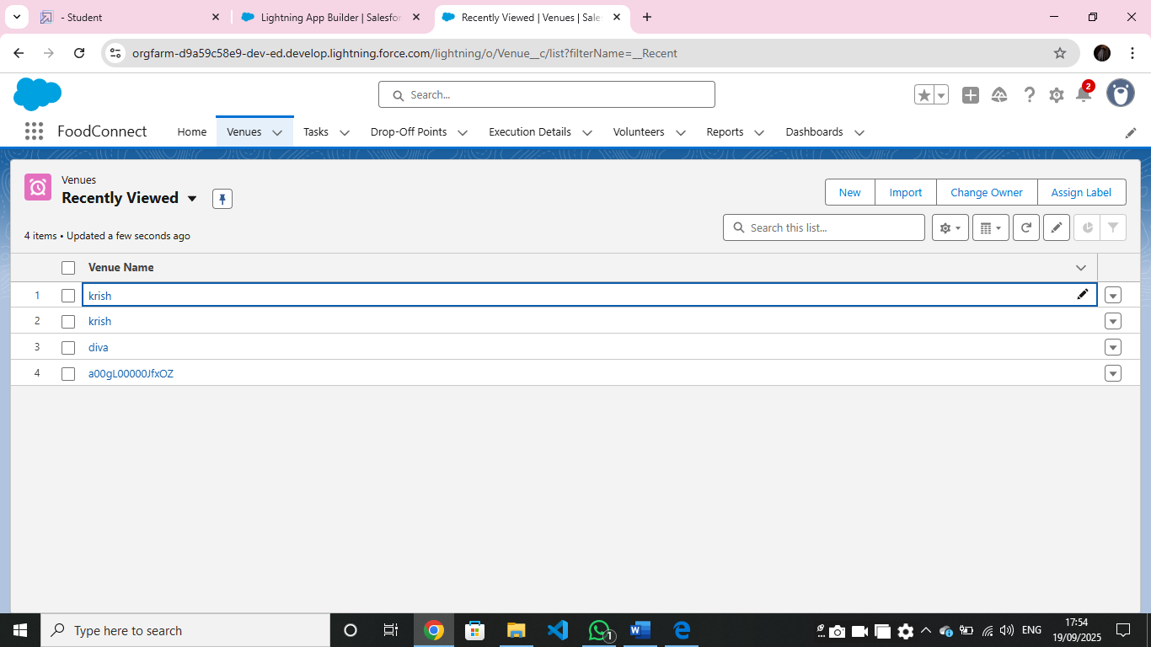
Conclusion
- The Food Distribution Project in Salesforce optimizes the process of collecting and distributing leftover food to those in need. By using Salesforce objects for Venue, Drop-Off Point, Task, Volunteer, and Execution Details, the project enables efficient tracking of food collection sites, distribution locations, and volunteer assignments. Automation through flows and triggers reduces manual tasks, while custom profiles and sharing rules ensure data security, allowing users to access only the information relevant to their roles.
- Real-time dashboards and reports provide valuable insights into distribution metrics, volunteer activity, and task progress, supporting data-driven decisions and resource allocation. A customized Home Page streamlines navigation by displaying recent activity, key metrics, and quick links. Overall, Salesforce empowers the project with enhanced organization, accountability, and scalability, making it an effective tool for addressing food distribution challenges and supporting communities in need.

